Note: please see the proposals in #project-proposals

(note: this eventually led to this paper: https://arxiv.org/abs/2502.20405)

<Dynamic Attention Scaling>

- Proposals must be specific and detailed so the direction of the research is clear.
- If you’re not sure about a given item, please mark it as such and we can discuss.

Relevant Past Papers
- Recycled Attention: Efficient inference for long-context language models
  - Reuse attention patterns of previous tokens that underwent full attention
  - Dynamically decide when to use recycled attention
  - 2x performance compared to long context baselines
  - Does not reduce memory usage. Limited test scope
- An Efficient Recipe for Long Context Extension via Middle-Focused Positional Encoding
  - Manipulates position indices and positional encodings
  - CREAM model encourages sampling from middle of context during fine-tuning
  - Can greatly extend context windows for open models
- MInference 1.0: Accelerating Pre-filling for Long-Context LLMs via Dynamic Sparse Attention
  - Identifies unique patterns in attention matrices that can improve efficiency and accelerate pre-filling of long-context
  - Maintains accuracy on common long-context benchmarks with 10x decrease in latency.
- Characterizing Mechanisms for Factual Recall in Language Models
  - Certain attention heads are responsible for promoting in-context, or memorized information
  - Scaling specific attention up or down can lead to generating in-context answers more often.
  - Currently, not a dynamic method

Motivation
One of the main issues with “Lost in the Middle” is the U-shaped attention curve, which disproportionately weights beginning and end tokens. In theory, by adjusting the curve such that it more equally weights all tokens, we can improve recall from the middle of long-contexts.

Key Contributions/Ideas

Methods
Given the U-shaped curve of the attention pattern, with low attention in the middle of the curve, we want to redistribute attention across the entire curve.
- Collect attention weights
- Calculate attention bias. Compare how much attention middle tokens receive compared to the beginning and end tokens. We can turn this into a ratio from 0 to 1. A value of 0.5 means that the middle tokens receive 50% of the attention given to beginning/end tokens on average.
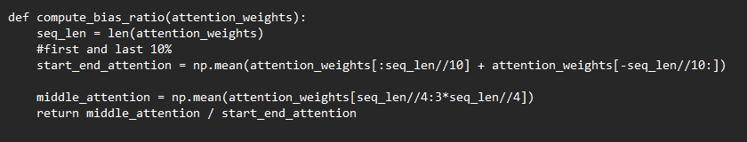
- Scale the attention curve: Generate a “U-shaped curve.” and a scaling curve based on the actual attention weights. The curve will have to be inverted (as we want the middle tokens to be scaled up), apply an adjustment factor (This needs work) such as (1-bias_ratio)*2. Then adjust the curve (curve ^ adjustment-factor) and normalize. Looks something like:
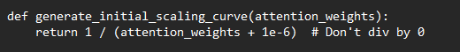
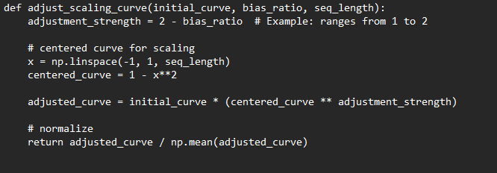
- Apply the adjusted attention to the model. After attention is computed in the transformer, we apply the adjusted weights. For example, in llama:
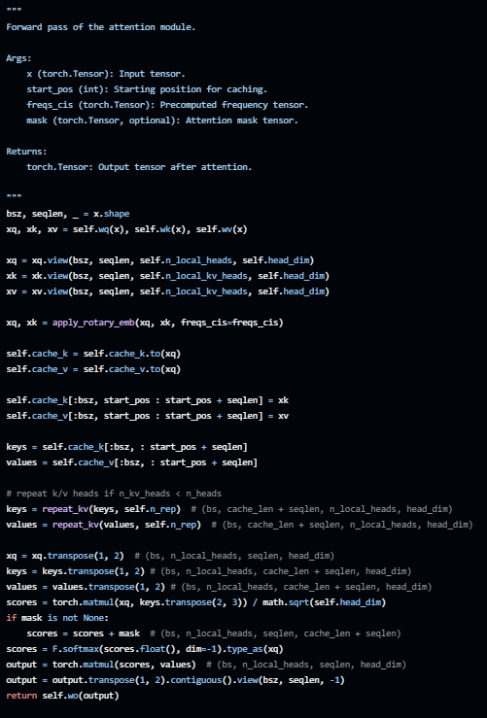
Before the masking process, we scale the weights by inserting the scaling factor:
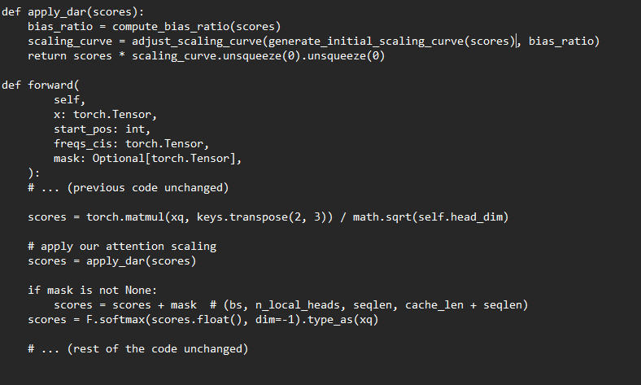

Experimental Setup
- How are you going to test your idea to prove that it works?
- What additional analysis do you plan on doing?
  - How are you going to prove that any improvements in the system are because of your idea alone, i.e. reduce confounding factors and do ablation testing
  - Visualizations? Statistics?

Datasets and Evaluation
- To compare accuracy/performance in long-context tasks, we can use common benchmarks that test different tasks such as LongBench, L-Eval, TriviaQA, Needle in Haystack, etc.

Benchmarks/Evaluation Sets
Also compare against other long-context techniques like fine-tuned models or various compression techniques in the benchmarks mentioned above.

Ideal Results
Improvements over baseline results in open models such as Llama, ideally without fine-tuning.

Potential Limitations
Base models may not be as accurate with the modified attention, and may need fine tuning to see improved results.

